**DEVELOP THE WEB APPLICATION USING NODE-RED**

|  |  |
| --- | --- |
| DATE | 8 November 2022 |
| TEAM ID | PNT2022TMID50829 |
| PROJECT NAME | Real-Time River Water Quality Monitoring and Control System |
| MARKS | 4 Marks |

1. Double-click the tab with the flow name, and call it Earthquake Details.

1. Click the hamburger menu, and then click **Manage palette**. Look for **node-red-node- open weather map** to install these additional nodes in your palette.

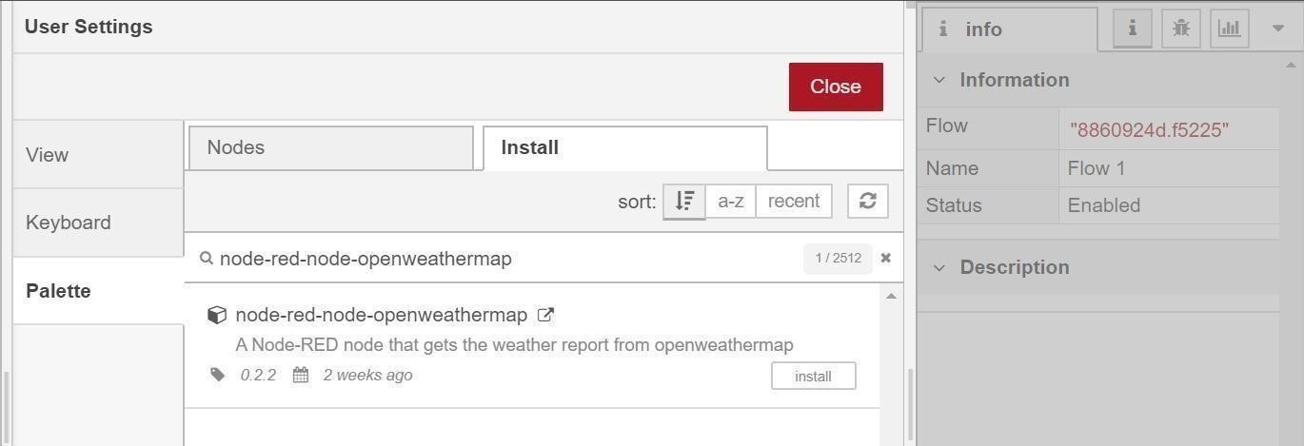

1. Add an **HTTP response** node, and connect it to the previously added **HTTP input** node. All other nodes introduced in this sub-section is to be added between the **HTTP input** node and the **HTTP response** node.
2. Add an **HTTP request** node and set the *URL* to

Add an **HTTP input** node to your flow.

Double-click the node to edit it. Set the method to GET and set the URL to

/earthquakeinfo-hr.

https://earthquake.usgs.gov/earthquakes/feed/v1.0/summary

/all_hour.geojson, the *Method* to **GET** and the *Return* to **a parsed JSON object**. This will allow extracting all earthquakes that occurred within the last hour. Name this node Get

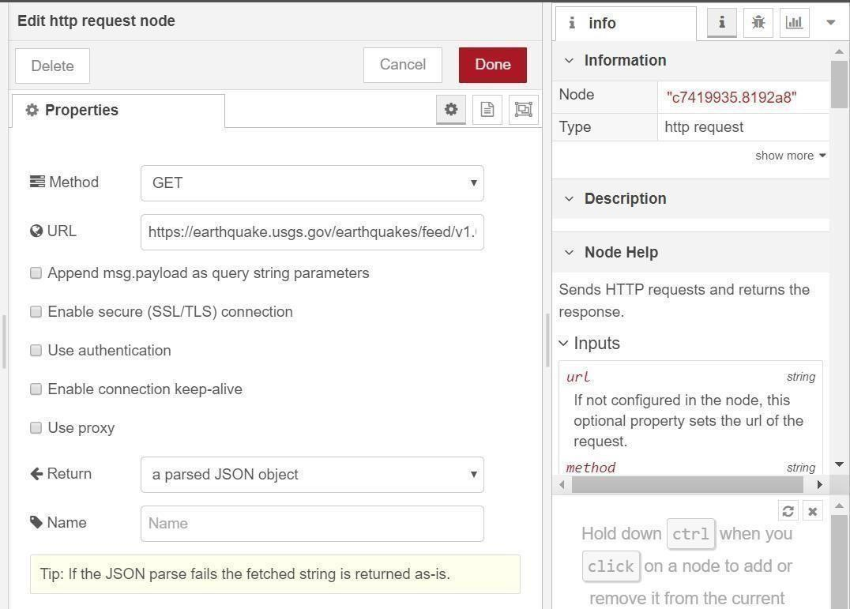

Add a **change** node. Double-click the node to modify it. Name this node Set

Earthquake Info. In

the **Rules** section, add rul to *Delete* es msg.topic,

msg.headers, msg.statusCode, msg.responseUrl and msg.redirectLis t and Set d payload.features. msg.payloa

{

"type":properties.type, "magnitude": properties.mag,

"location": properties.place,

"longitude":geometry.coordinates[0],

"latitude":geometry.coordinates[1],

"depth":geometry.coordinates[2],

"timestamp": $fromMillis( properties.time,